**BANK LOAN PROJECT QUERY DOCUMENT**

**BANK LOAN REPORT | SUMMARY**

"In order to monitor and assess our bank's lending activities and performance, we need to create a comprehensive Bank Loan Report. This report aims to provide insights into key loan-related metrics and their changes over time. The report will help us make data-driven decisions, track our loan portfolio's health, and identify trends that can inform our lending strategies.

**A. KPI’s**

**1. Total Loan Applications**: We need to calculate the total number of loan applications received during a specified period. Additionally, it is essential to monitor the Month-to-Date (MTD) Loan Applications and track changes Month-over-Month (MoM).

**-- Total Loan Application**

**Query:** SELECT COUNT (id) as Total_Loan_Application FROM BankLoanData;



**-- Total Loan Application for MTD**

**Query:** SELECT COUNT(id) as MTD_Total_Loan_Application FROM BankLoanData

WHERE MONTH(issue_date) = 12;



**-- Total Loan Application for PMTD**

**Query:** SELECT COUNT (id) as PMTD_Total_Loan_Application FROM BankLoanData

WHERE MONTH (issue_date) = 11;



**2. Total Funded Amount:** Understanding the total amount of funds disbursed as loans is crucial. We also want to keep an eye on the MTD Total Funded Amount and analyse the Month-over-Month (MoM) changes in this metric.

**--Total Funded Amount**

**Query:** SELECT SUM(loan_amount) AS Total_Funded_Amount FROM BankLoanData;



**--Total Funded Amount for MTD**

**Query:** SELECT SUM(loan_amount) AS MTD_Total_Funded_Amount FROM BankLoanData

WHERE MONTH(issue_date) = 12;



**--Total Funded Amount for PMTD**

**Query:** SELECT SUM(loan_amount) AS PMTD_Total_Funded_Amount FROM BankLoanData

WHERE MONTH(issue_date) = 11;



**3. Total Amount Received:** Tracking the total amount received from borrowers is essential for assessing the bank's cash flow and loan repayment. We should analyse the Month-to-Date (MTD) Total Amount Received and observe the Month-over-Month (MoM) changes.

**--Total Amount Received**

**Query:** SELECT SUM(total_payment) AS Total_Amount_Received FROM BankLoanData;



**--Total Amount Received for MTD**

**Query:** SELECT SUM(total_payment) AS MTD_Total_Amount_Received FROM BankLoanData

WHERE MONTH(issue_date) = 12;



**--Total Amount Received for PMTD**

**Query:** SELECT SUM(total_payment) AS PMTD_Total_Amount_Received FROM BankLoanData

WHERE MONTH(issue_date) = 11;



4. **Average Interest Rate:** Calculating the average interest rate across all loans, MTD, and monitoring the Month-over-Month (MoM) variations in interest rates will provide insights into our lending portfolio's overall cost.

**-- Average Interest Rate**

**Query:** SELECT ROUND(AVG(int_rate)*100,2) AS Average_Int_Rate FROM BankLoanData;



**-- Average Interest Rate for MTD**

**Query:** SELECT ROUND(AVG(int_rate)*100,2) AS MTD_Average_Int_Rate FROM BankLoanData

WHERE MONTH(issue_date) = 12;



**-- Average Interest Rate for PMTD**

**Query:** SELECT ROUND(AVG(int_rate)*100,2) AS PMTD_Average_Int_Rate FROM BankLoanData

WHERE MONTH(issue_date) = 11;



**5. Average Debt-to-Income Ratio (DTI):** Evaluating the average DTI for our borrowers helps us gauge their financial health. We need to compute the average DTI for all loans, MTD, and track Month-over-Month (MoM) fluctuations.

**-- Average Debt to Ratio**

**Query:** SELECT ROUND(AVG(dti)*100,2) AS Average_DTI FROM BankLoanData;



**-- Average Debt to Ratio for MTD**

**Query:** SELECT ROUND(AVG(dti)*100,2) AS MTD_Average_DTI FROM BankLoanData

WHERE MONTH(issue_date) = 12;



**-- Average Debt to Ratio for PMTD**

**Query:** SELECT ROUND(AVG(dti)*100,2) AS PMTD_Average_DTI FROM BankLoanData

WHERE MONTH(issue_date) = 11;



**Good Loan v Bad Loan KPI’s:**

In order to evaluate the performance of our lending activities and assess the quality of our loan portfolio, we need to create a comprehensive report that distinguishes between 'Good Loans' and 'Bad Loans' based on specific loan status criteria.

**Good Loan KPIs:**

**1. Good Loan Application Percentage:** We need to calculate the percentage of loan applications classified as 'Good Loans.' This category includes loans with a loan status of 'Fully Paid' and 'Current.'

**Query:** SELECT (COUNT(CASE WHEN loan_status in ('Fully Paid','Current') THEN id END)*100) /

COUNT(id) AS Good_Loan_Percentage FROM BankLoanData;



**2. Good Loan Applications:** Identifying the total number of loan applications falling under the 'Good Loan' category, which consists of loans with a loan status of 'Fully Paid' and 'Current.'

**Query:** SELECT COUNT(id) AS Good_Loan_Applications FROM BankLoanData

WHERE loan_status in ('Fully Paid','Current');



3. **Good Loan Funded Amount:** Determining the total amount of funds disbursed as 'Good Loans.' This includes the principal amounts of loans with a loan status of 'Fully Paid' and 'Current.'

**Query:** SELECT SUM(loan_amount) AS Good_Loan_Funded_Amount FROM BankLoanData

WHERE loan_status in ('Fully Paid','Current');



**4. Good Loan Total Received Amount:** Tracking the total amount received from borrowers for 'Good Loans,' which encompasses all payments made on loans with a loan status of 'Fully Paid' and 'Current.'

**Query:** SELECT SUM(total_payment) AS Good_Loan_Total_Amount_Received FROM BankLoanData

WHERE loan_status in ('Fully Paid','Current');



**Bad Loan KPIs:**

**1. Bad Loan Application Percentage:** Calculating the percentage of loan applications categorized as 'Bad Loans.' This category specifically includes loans with a loan status of 'Charged Off’.

**Query:** SELECT (COUNT(CASE WHEN loan_status = 'Charged Off' THEN id END)*100.0)/

COUNT(id) AS Bad_Loan_Percentage FROM BankLoanData;



**2. Bad Loan Applications:** Identifying the total number of loan applications categorized as 'Bad Loans,' which consists of loans with a loan status of 'Charged Off.'

**Query:** SELECT COUNT(id) AS Bad_Loan_Application FROM BankLoanData

WHERE loan_status = 'Charged Off';



**3. Bad Loan Funded Amount:** Determining the total amount of funds disbursed as 'Bad Loans.' This comprises the principal amounts of loans with a loan status of 'Charged Off.'

**Query:** SELECT SUM(loan_amount) AS Bad_Loan_Funded_Amount FROM BankLoanData

WHERE loan_status = 'Charged Off';



**4. Bad Loan Total Received Amount:** Tracking the total amount received from borrowers for 'Bad Loans,' which includes all payments made on loans with a loan status of 'Charged Off.'

**Query:** SELECT SUM(total_payment) AS Bad_Loan_Total_Amount_Received FROM BankLoanData

WHERE loan_status = 'Charged Off';



**Loan Status Grid View**

In order to gain a comprehensive overview of our lending operations and monitor the performance of loans, we aim to create a grid view report categorized by 'Loan Status.' This report will serve as a valuable tool for analysing and understanding the key indicators associated with different loan statuses. By providing insights into metrics such as 'Total Loan Applications,' 'Total Funded Amount,' 'Total Amount Received,' 'Month-to-Date (MTD) Funded Amount,' 'MTD Amount Received,' 'Average Interest Rate,' and 'Average Debt-to-Income Ratio (DTI),' this grid view will empower us to make data-driven decisions and assess the health of our loan portfolio.

**Query:** SELECT

loan_status,

COUNT(id) AS Total_Loan_Applications,

SUM(loan_amount) AS Total_Amount_Funded,

SUM(total_payment) AS Total_Amount_Received,

ROUND(AVG(int_rate)*100,2) AS Interest_Rate,

ROUND(AVG(dti)*100,2) AS Debt_to_income_Ratio

FROM BankLoanData

GROUP BY loan_status;

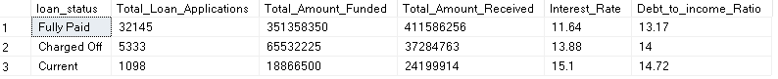

**-- MTD Amount Received and Funded**

SELECT

loan_status,

SUM(loan_amount) AS MTD_Total_Amount_Funded,

SUM(total_payment) AS MTD_Total_Amount_Received

FROM BankLoanData

WHERE MONTH(issue_date) = 12

GROUP BY loan_status;

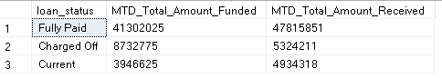

**BANK LOAN REPORT | OVERVIEW**

In our Bank Loan Report project, we aim to visually represent critical loan-related metrics and trends using a variety of chart types. These charts will provide a clear and insightful view of our lending operations, facilitating data-driven decision-making and enabling us to gain valuable insights into various loan parameters. Below are the specific chart requirements:

**1. Monthly Trends by Issue Date (Line Chart**): This line chart will showcase how 'Total Loan Applications,' 'Total Funded Amount,' and 'Total Amount Received' vary over time, allowing us to identify seasonality and long-term trends in lending activities.

**Metrics:** 'Total Loan Applications,' 'Total Funded Amount,' and 'Total Amount Received'

**X-Axis:** Month (based on 'Issue Date'), **Y-Axis:** Metrics' Values

**Query:** SELECT

MONTH(issue_date) AS Month_No,

DATENAME(MONTH, issue_date) AS Month_Name,

COUNT(id) AS Total_Loan_Applications,

SUM(loan_amount) AS Total_Amount_Funded,

SUM(total_payment) AS Total_Amount_Received

FROM BankLoanData

GROUP BY MONTH(issue_date), DATENAME(MONTH, issue_date)

ORDER BY MONTH(issue_date);

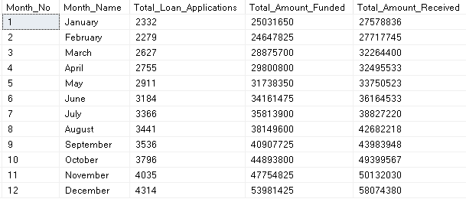

2. **Regional Analysis by State (Filled Map):**This filled map will visually represent lending metrics categorized by state, enabling us to identify regions with significant lending activity and assess regional disparities.

**Metrics:** 'Total Loan Applications,' 'Total Funded Amount,' and 'Total Amount Received'

**Geographic Regions:** States

**Query:** SELECT

address_state,

COUNT(id) AS Total_Loan_Applications,

SUM(loan_amount) AS Total_Amount_Funded,

SUM(total_payment) AS Total_Amount_Received

FROM BankLoanData

GROUP BY address_state

ORDER BY address_state;

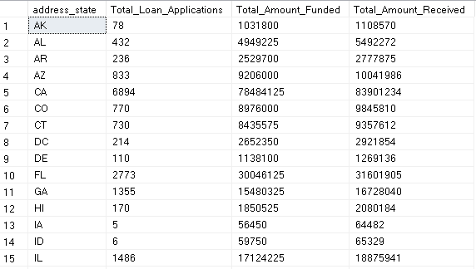

**3. Loan Term Analysis (Donut Chart**): This donut chart will depict loan statistics based on different loan terms, allowing us to understand the distribution of loans across various term lengths.

**Metrics:** 'Total Loan Applications,' 'Total Funded Amount,' and 'Total Amount Received'

**Segments:** Loan Terms (e.g., 36 months, 60 months)

Query: SELECT

term,

COUNT(id) AS Total_Loan_Applications,

SUM(loan_amount) AS Total_Amount_Funded,

SUM(total_payment) AS Total_Amount_Received

FROM BankLoanData

GROUP BY term

ORDER BY term;



**4. Employee Length Analysis (Bar Chart):** This bar chart will illustrate how lending metrics are distributed among borrowers with different employment lengths, helping us assess the impact of employment history on loan applications.

**Metrics:** 'Total Loan Applications,' 'Total Funded Amount,' and 'Total Amount Received'

**X-Axis:** Employee Length Categories (e.g., 1 year, 5 years, 10+ years), **Y-Axis:** Metrics' Values

**Query:** SELECT

emp_length AS Employee_Length,

COUNT(id) AS Total_Loan_Applications,

SUM(loan_amount) AS Total_Amount_Funded,

SUM(total_payment) AS Total_Amount_Received

FROM BankLoanData

GROUP BY emp_length

ORDER BY emp_length;

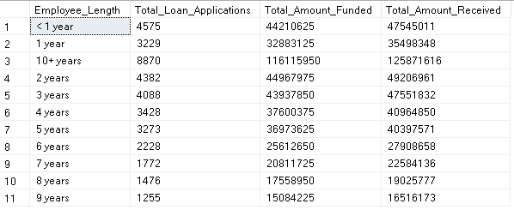

**5. Loan Purpose Breakdown (Bar Chart):** This bar chart will provide a visual breakdown of loan metrics based on the stated purposes of loans, aiding in the understanding of the primary reasons borrowers seek financing.

**Metrics:** 'Total Loan Applications,' 'Total Funded Amount,' and 'Total Amount Received'

**X-Axis:** Loan Purpose Categories (e.g., debt consolidation, credit card refinancing), **Y-Axis:** Metrics' Values

**Query:** SELECT

purpose AS Loan_Purpose,

COUNT(id) AS Total_Loan_Applications,

SUM(loan_amount) AS Total_Amount_Funded,

SUM(total_payment) AS Total_Amount_Received

FROM BankLoanData

GROUP BY purpose

ORDER BY count(id) DESC;

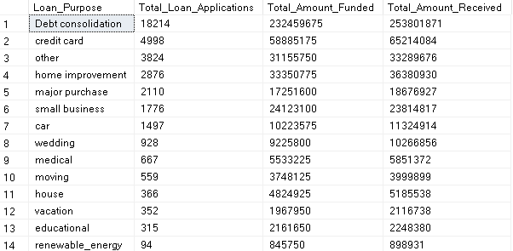

**6. Home Ownership Analysis (Tree Map):** This tree map will display loan metrics categorized by different home ownership statuses, allowing for a hierarchical view of how home ownership impacts loan applications and disbursements.

**Metrics:** 'Total Loan Applications,' 'Total Funded Amount,' and 'Total Amount Received'

**Hierarchy:** Home Ownership Categories (e.g., own, rent, mortgage)

**Query:** SELECT

home_ownership,

COUNT(id) AS Total_Loan_Applications,

SUM(loan_amount) AS Total_Amount_Funded,

SUM(total_payment) AS Total_Amount_Received

FROM BankLoanData

GROUP BY home_ownership

ORDER BY count(id) DESC;

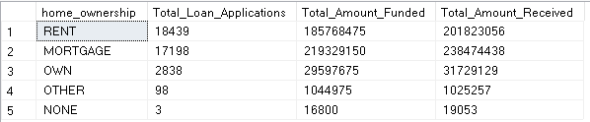

**BANK LOAN REPORT | DETAILS**

In our Bank Loan Report project, we recognize the need for a comprehensive 'Details Dashboard' that provides a consolidated view of all the essential information within our loan data. This Details Dashboard aims to offer a holistic snapshot of key loan-related metrics and data points, enabling users to access critical information efficiently.

**GRID VIEW:**

**Objective:**

The primary objective of the Details Dashboard is to provide a comprehensive and user-friendly interface for accessing vital loan data. It will serve as a one-stop solution for users seeking detailed insights into our loan portfolio, borrower profiles, and loan performance.